Week 4 Day 1: PA Warm-up

read_xlsx()
- What’s wrong with the top of the gov_spending_per_capita.xlsx spreadsheet?
- Fill in the code you would need to read in the cleanest version of these data.
military <- read_xlsx("gov_spending_per_capita.xlsx",
sheet =
skip =
n_max =
)
- What are the three ways NA values were coded in these data?
- What would you input into the na = argument of read_xlsx() to recode these values as NAs?

pivot_longer()
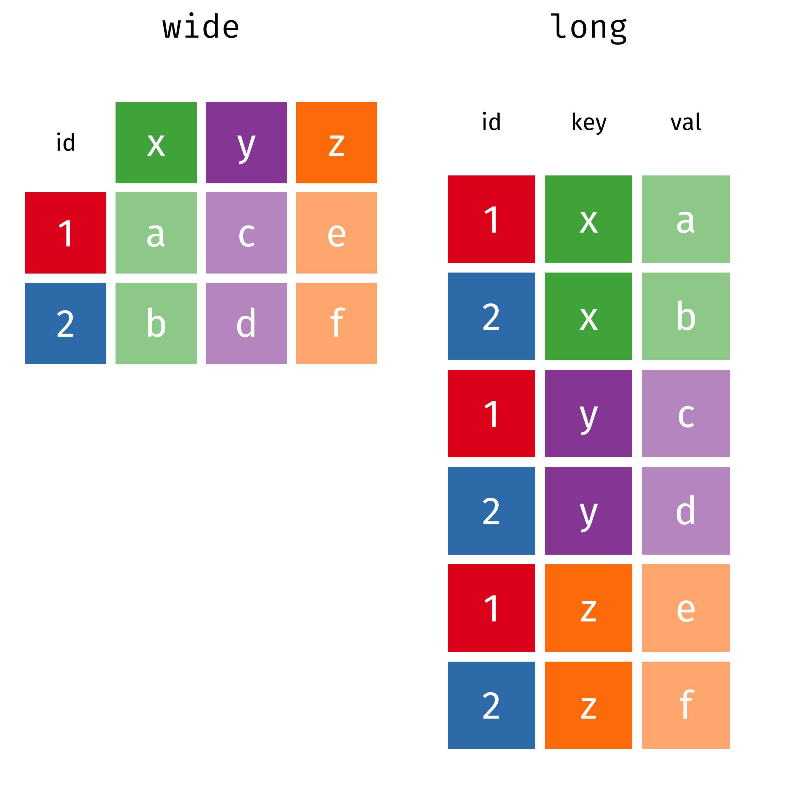
- Why don’t we want to pivot our data manually?
- Fill in the code below to pivot the military data from wide to long:
military |>
pivot_longer(cols =
names_to =
values_to =
)
- What do you notice is weird about some of the values of Country?

if_any() & if_all()
These functions are used with filter() to select rows based on a logical statement applied to multiple columns
- if_any() – returns a logical vector (one element for each row) that is TRUE if the logical statement is true for any column in the supplied columns
- if_all() – returns a logical vector (one element for each row) that is TRUE if the logical statement is true for all columns in the supplied columns
- Fill in the code to filter() the military data to only include observations that have at least one missing value for the military spending:
military |>
filter(
if_any(
.cols =
.fns =
)
)

