Practice Activity 2 Warm-up

Data Context
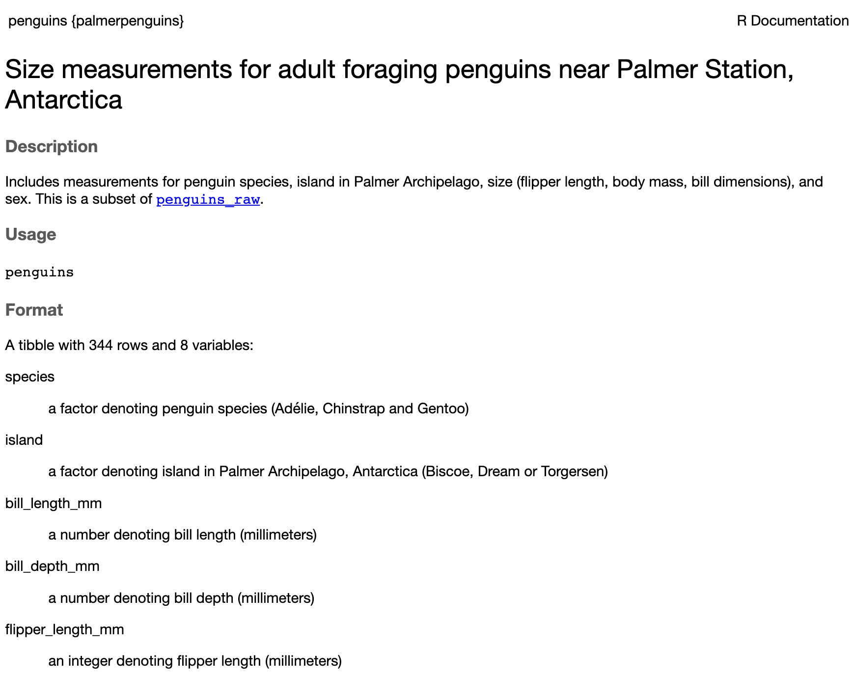 What variables are included in these data? What units are the variables measured in? What do you think each row in the data represents?

Grammar of Graphics
Think of a graph or a data visualization as a mapping…
…FROM variables in the data set (or statistics computed from the data)…
…TO visual attributes (or “aesthetics”) of marks (or “geometric elements”) on the page/screen.

How to Build a Graphic with ggplot2
ggplot(data = penguins)
What do you expect to see after running this code?
ggplot(data = penguins,
mapping = aes(x = species, y = bill_length_mm)
)
What do you expect to see after running this code?
ggplot(data = penguins,
mapping = aes(x = species, y = bill_length_mm)
) +
geom_jitter() +
geom_boxplot()
What do you expect to see after running this code?

aesthetics & geometries
Common aesthetics
- x, y
- color, fill
- linetype
- shape
- size
Common geometries
- geom_bar()
- geom_density()
- geom_histogram()
- geom_boxplot()
- geom_point()
- geom_line()

PA 2 Warm-up

Create a plot showing the number of penguins captured on each island
- What type of variable is island?
- What type of plot would you make for this type of variable?
- What geom would you use to get this plot?

Create plot displaying the most common bill lengths for the penguins in these data
- What type of variable is bill_length_mm?
- What type of plot would you make for this type of variable?
- What geom would you use to get this plot?

Create a plot showing the relationship between a penguin’s bill length and body mass
- What type of variables are bill_length_mm and body_mass_g?
- What type of plot would you make for this type of variable?
- What geom would you use to get this plot?

